 | 12/2/2025

to: | Dr. Matthew Stapleton
from: | Marin Aske
subject: | Tutorial Evaluation

CC:
INTRODUCTION
With this memo, I provide an evaluation of the tutorial created by me entitled “How to Download Steam and play your first game.” I chose this topic because Steam is among the most widely used game platforms, yet a lot of new users, especially those migrating from console systems or unfamiliar with PC gaming platforms, face difficulties in using it for the first time. I also chose this topic because this assignment combines several common digital literacy skills: downloading software, creating an online account, navigating a digital store, and launching installed applications. Such tasks are universal and applicable beyond Steam, therefore making the tutorial both practical and relevant.
My tutorial is designed to walk the beginning user through the steps necessary to get started with Steam safely and confidently. Because its purpose is limited to initial setup and first-time use, it only covers how to download Steam, create an account, buy one game, and launch that game. I drafted the tutorial according to Redish's principles on designing effective writing for online content: chunking information, prioritizing the needs of users, and using plain language.
The target audience for this tutorial comprises first-time users of either Steam or PC gaming. These individuals might be fairly familiar with computers but lack confidence when trying to use huge online platforms. They may seek entrance to a certain game or learn how to use Steam safely without making mistakes that may lead to their account's compromise. The tutorial gives them a structured walk-through they can follow at their own pace and return to whenever needed.
In general, I believe that a novice user will find my tutorial particularly effective because it communicates and shares complex digital tasks in a straightforward, user-centered, minimalist format. The online writing and design principles by Redish and the course readings were applied to ensure an accessible and easy-to-follow instructional sequence.
The rest of this memo will discuss the tutorial within the larger tutorial genre, explain the key decisions we made regarding content, organization, writing style, and design, demonstrate those choices through example illustrations, address the software tools used, and conclude with a reflection on the challenges and lessons learned.

BACKGROUND - The Tutorial Genre
Tutorials as a genre are instructional documents that enable users to complete a task through a series of steps that they follow. Tutorials are task-oriented, user-centered, and meant to be followed linearly. Tutorials stand apart from reference materials or conceptual documents, since tutorials focus on action-not theory. As Redish explains, users "come to the web to get answers, not to read long explanations" (p. 112). This principle shapes the tutorial genre, supporting short steps and clear instructions with accompanying visuals.
My tutorial fits squarely in the software program tutorial genre through its step-by-step structure, its action-first phrasing, and its emphasis on doing rather than explaining in terms of actions on a program on your system. My tutorial makes no attempt to describe the history of Steam or to give elaborate descriptions of gaming platforms. Rather, it focuses narrowly on what the user needs to do to complete the tasks. In this, I follow the injunction that online help must “give people only what they need—no more, no less” (Redish, p. 189).
CONTENT AND ORGANIZATIONAL DECISIONS
I organized this tutorial into four major task sections:
1. Download and install Steam
2. Make a Steam account
3. Buy a game
4. Launch the game
I have chosen this order because of the natural workflow a new Steam user would generally go through: A user cannot create an account without the application, and they cannot buy a game without the account, nor can they launch one without purchasing or installing. This linear structure also aligns with Redish's guidance to "organize content by the user's tasks" rather than by the system's internal logic (p. 97).
Every section starts with a short preview sentence that sets up what the user will do and why the action counts. This reinforces motivation and prepares the user for the next steps. In each section, I used step numbers to encourage clear progression. Research in UX shows users prefer numbered lists when sequence matters. Screenshots are placed at moments when users might hesitate or need visual validation-for example, the Steam installer window, or the "Create Account" button. These screenshots serve as visual anchors, reducing the cognitive load on new users.
I avoided adding anything not relevant to the scope of this task. For example, Steam has community features, friends list, and achievement systems, but these have intentionally been omitted to keep focus and not overwhelm the user. As Redish states, effective tutorials “respect the user’s time by eliminating distractions” (p. 146).

Prose Style and Minimalist Writing
Because the audience consists of novice users, I adopted a straightforward, conversational tone while keeping sentences short and direct. My prose makes use of action verbs at the beginning of steps, “Click,” “Open,” “Select,” “Install”, helping users skim effectively and immediately understand what to do next. The paragraphs are short, and the chunks of information are presented in easily-digested units, following Redish’s principle that users “do not read—they scan” (p. 25).

I used plain language wherever possible. Instead of saying "execute the installer", for instance, the tutorial simply says, "double-click the file". This reduces intimidation and supports users with lower technical literacy. At the same time, I preserved necessary terminology when it was unavoidable, always presenting it in context so that users know precisely what to look for.
Minimalism was a key stylistic objective: I eschewed long explanations, jargon, and other unnecessary details. Redish sums it up: writing that is “short, simple and centered on the user’s needs at that moment” (p. 162). Because each step only says what users need to act, and no step has more than one action, users will make fewer errors and get through the tutorial more smoothly.
DESIGN ELEMENTS
Several design decisions support the tutorial clarity, accessibility, and effectiveness:

CONSISTENT HEADERS AND SUBHEADINGS
Each activity leads off with a standard header naming the action. Sub-headings (“What you will do” and “Steps”) serve to organize the content into predictable sections. Consistency enhances usability by letting users know what to expect.

SPACING AND JUSTIFICATION
Following the instructions, I used left-justified text and single spacing, placing a blank line between paragraphs. This design prevents large blocks of text and offers better readability, particularly on screens—supporting Redish's point that online text must be visually easy to scan (p. 54).

NUMBERED AND BULLETED LISTS
Lists let structure be clearly conveyed. Numbered lists enumerate steps; bulleted lists define concepts or optional information. This lets the user know what is sequential and what is descriptive at all times.

SCREENSHOTS
The screenshots appear directly after the step they support. This avoids forcing the user to flip pages or scroll back and forth. Screenshots are cropped so only relevant interface elements are shown to avoid distraction.

DISPLAYED EXAMPLES
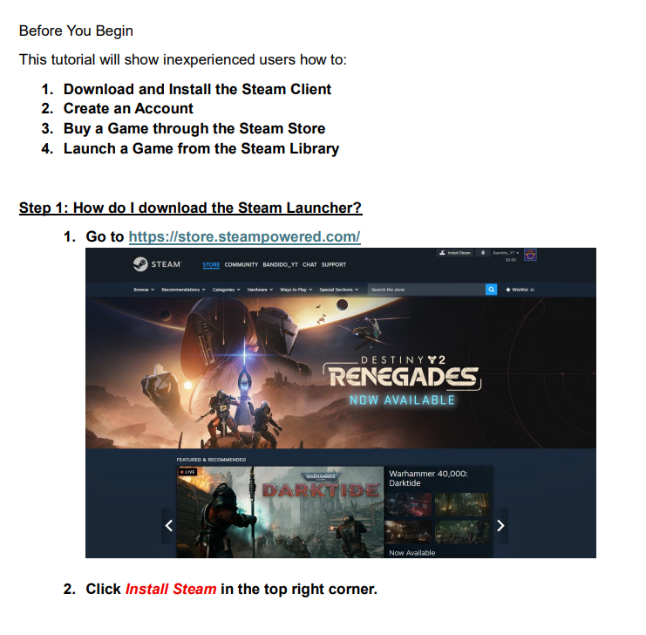
These visual examples reinforce how the design principles translate into practice.
SOFTWARE TOOLS USED
I created the tutorial using Microsoft Word with one of the internal templates. The reason for choosing Word was that it supports consistent heading styles, facilitates the placement of screenshots, and provides a smooth workflow regarding exporting to PDF. Images of the interface were captured using the built-in screenshot tool, Windows Snipping Tool.
One problem I faced was how to get stable formatting when adding screenshots in here. Word sometimes changes spacing or aligns photos of its own accord. To resolve this, I set images to “In line with text,” which prevented formatting breakage when converting to PDF.
Converting the document to PDF also made minor font-rendering issues. I resolved this by using standard system fonts and avoiding decorative fonts - in line with guidance from accessibility documents such as the Governor’s Office PDF conversion guide linked in the assignment prompt. If I were producing a more complex tutorial, I might consider a dedicated help-authoring tool such as MadCap Flare, but for this project, Word was sufficient and efficient.

CONCLUSION
This tutorial provided many challenges when it came to choosing the right amount of detail for a beginning user, effectively balancing the clarity of text with screenshots, and dealing with formatting issues translating from Word to PDF. I had also to apply principles of online writing throughout, especially on writing minimally, organizing content by user tasks, and designing for scanability. In the process, I learned the importance of considering user motivation and cognitive load in designing instructions. Even minor decisions, such as the placing of screenshots or the phrasing of steps, greatly affect usability. If I were to revise this tutorial, I would try adding optional "Troubleshooting" sidebars or a short glossary for complete beginners, but I would have to make sure such additions did not clutter the design. On the whole, it greatly strengthened my understanding of user-centered writing and online content design, reinforcing principles from Redish and other course readings in a meaningful and practical way.

